- OBJECTIVE

This document aims to present the characteristics and requirements for a new test system concept, the Modular All Drives, which consists of the development of a modular, compact and automated test platform, designed to separate each test stage into an independent module, ensuring all stages necessary for validation of products from the Orion line (mechanical sizes D, E and F) and similar WEG drives (CFW900 and CFW11, mechanical sizes C, D and E).
The system encompasses automated electrical connections, drive hardware, control software, safety systems and an integrated conveyor system in a single solution, allowing greater standardization, operational flexibility, setup reduction and optimization of the production process.
Within this concept, the present scope aims at the manufacturing of two main test modules: a combined hipot and functional test module, responsible both for ensuring the electrical insulation of the power connections of the drives (hipot) and for the electrical, logical and operational validation of the products (functional), and a load test module, intended for the simulation of real operating conditions through the application of controlled load on the tested drives.

NOTE: The devices represented in this document are for illustrative purposes only, serving for explanation of the concepts. All details of the final project must be discussed and validated for the supply, as well as the supplier may (and should) propose improvements aiming at the technical enhancement of the solution.

- GENERAL DEFINITIONS

The project refers to the supply of a combined hipot and functional test module and an automated load test module intended for validation of the functionalities of products from the Orion line (mechanical sizes D, E and F) and similar WEG drives (CFW900 and CFW11, mechanical sizes C, D and E).

Hipot and Functional Test Module:
The hipot and functional test module consists of a single station dedicated to the execution of both the dielectric (hipot) test and the functional test on products from the Orion line (mechanical sizes D, E and F) and similar WEG drives (CFW900 and CFW11, mechanical sizes C, D and E). In this module the power connections are separated from the control/IO connections: the hipot test is executed first using only the power connections and, afterwards, the control/IO connections are engaged and the functional test is executed with both the power and the control connections. During the hipot test only the power connections shall be connected; during the functional test both the power and the control connections shall be connected. The hipot stage validates the integrity of the electrical insulation and ensures the conformity of the product with the electrical safety requirements established by the applicable technical specifications.
The proposed concept encompasses an independent, compact and modular module, integrated into the production line, allowing the execution of the hipot test in an automated, safe and standardized manner.
The system shall have its own conveyor, enabling the automatic transportation of the fixtures to the dedicated test position.

Upon arriving at the station, the product shall be automatically transferred to the test area, where the coupling of the electrical connections necessary for the application of the test voltage shall occur.
The module shall have all devices necessary for execution of the test, including the hipot tester, protection devices, automatic grounding, discharge circuits, safety monitoring and electrical and mechanical interlocks.
Due to the critical nature of the test, the module shall have a safety enclosure with monitored access, ensuring the safety of the operators during execution of the test. The system shall automatically prevent the opening of the test area during the application of high voltage, in addition to performing the safe discharge of the product at the end of the test cycle. The module shall have wiring with insulation level for up to 4 kV in order to avoid leakage and noise.
The module shall include integration with the supervisory system and test software, allowing automatic identification of the product through QR Code reading, loading of the corresponding recipe, recording of test results and traceability of process information.

Functional Test Stage:
The proposed concept consists of a compact, modular and scalable test stage, developed to execute functional test routines on the products, ensuring that all functionalities of the drive are in accordance with the test specifications and that the product is considered approved for use.
The module shall have its own conveyor integrated into the structure of the equipment, responsible for the movement of the fixtures containing the products along the production line. The product shall automatically travel on the conveyor to the region of the test module, where it shall be removed from the line and transferred to a dedicated functional test position. This architecture shall allow keeping the main conveyor free for continuity of the production flow and future expansions of the line.
The system shall integrate in a single equipment all hardware necessary for drives, measurements, protections and execution of the tests, eliminating the need for additional external panels.
For automatic identification of the product under test, the module shall have a QR Code reading system, responsible for identifying the drive and automatically loading the corresponding test recipe.
In addition, the module shall have an integrated vision system applied only to verify that the HMI is working correctly.

The tests to be executed are:
- External energization of the control, validation of measurement and operation of the HMI;
- Energization of the product through the power section, validation of link measurement, generated control power supplies;
- Firmware version verification;
- I/Os;
- Serial number programming;
- MAC address programming;
- Ethernet ports;
- USB port;
- Internal battery validation;
- RS-485 communication;
- Motor operation and output current measurement;
- Validation of the safety stop module;
- Rheostatic braking;
- Test of ground fault and output short-circuit protections;
- Programming of factory default parameters.

These tests shall be executed in an automatic sequential manner, controlled by a WEG PLC500, using a human-machine interface for visualization and control, which may be a computer or a touch screen.
On this screen there shall be monitoring of the tests in progress, as well as detailed display of the information of the test results, whether approval or rejection, tools for manual execution of the tests, monitoring of the drives and registration of new products into the system.
The module shall have its own supervisory software that allows integration with the supervisory software of the other modules. Each module shall have its own independent conveyor, allowing new modules to be added side by side in a simple manner, without the need for complex mechanical couplings between conveyors. The concept shall prioritize ease of replication, modularity and global standardization.
The products shall be assembled on dedicated fixtures, responsible for mechanical positioning, electrical connection and interface with the test system. These fixtures shall have connectors and harnesses previously connected to the product, and shall have, in some part of the fixture, electrical contact pads, connectors or similar elements that make the connection between the system and the fixture under test.
The system shall support currents up to 250 A and voltages of 220 V, 440 V, 575 V and 690 V. The fixtures shall support products with mass up to 120 kg without deformations or loss of dimensional accuracy.

Load Test Module:
The load test module consists of a station dedicated to the execution of load tests on products from the Orion line (mechanical sizes D, E and F) and similar WEG drives (CFW900 and CFW11, mechanical sizes C, D and E), with the objective of validating the functional behavior, electrical performance, taking the product to maximum stress with the heated cabin.
The proposed concept encompasses an independent, compact, modular and scalable module, integrated into the production line and developed to automatically execute the load test routines according to the recipe defined for each product model.
The system shall allow the controlled application of load on the equipment under test, enabling validation of electrical parameters, operational response, operating stability, protections and other characteristics defined by the test specification.
The module shall have its own structure for automatic movement of the fixtures containing the products, and may operate integrated with the main conveyor of the line or through a dedicated transfer system. Upon arriving at the test position, the product shall be automatically coupled to the system of electrical connections and interfaces necessary for execution of the tests.
All infrastructure necessary for execution of the tests shall be integrated into the module, including power systems, drive devices, electrical protections, measurement systems, communication interfaces, wiring, ventilation and other components necessary for safe and continuous operation of the equipment, without the need for additional external panels.
The module shall use electronic loads as load for the drives, which shall be supplied by WAU.
The system shall support currents up to 250 A and voltages of 220 V, 440 V, 575 V and 690 V. It shall also have a heated cabin controllable up to 50°C.
The system shall have supervisory software and test software, allowing automatic identification of the product through QR Code reading, automatic loading of the test recipe, parameterization of the tests, real-time data acquisition, recording of results and traceability of process information. It shall also allow integration with the other supervisory software of the other modules.
In addition, the module shall be designed considering operational safety criteria, ease of maintenance, accessibility to internal components, adequate thermal dissipation and possibility of future expansion for new products, power ratings and test architectures, maintaining the modular and standardized concept of the Modular All Drives system.

General Characteristics for the Modules:
- 380 Vac 60 Hz power supply;
- The mechanical design of the modules shall be as compact as possible considering factory floor space savings;
- Approximate cycle times: Hipot test < 1 min, Functional test < 5 min, Load test < 20 min, however the times will depend on the product and the test routine employed;
- Fixture made of resistant material and with lifting points or handling points;
- Consider 5 types of fixtures with 3 units per type, totaling 15 fixtures, each fixture type shall be made according to a type of product to be mechanically fixed;
- The largest product to be tested shall have H x D x W = 675 mm x 358 mm x 335 mm, the fixture shall accommodate the product and all wiring;
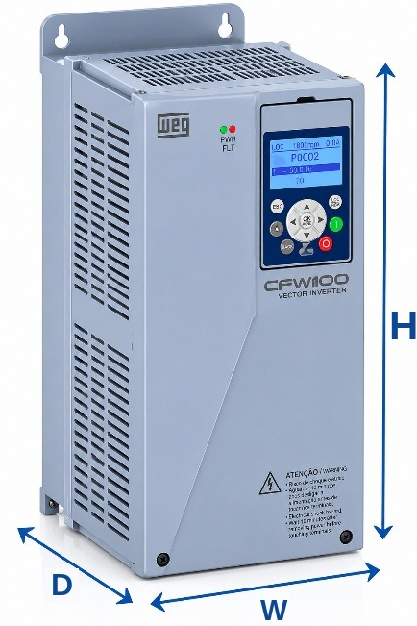
- All fixtures shall have standardized dimensions. The only variation among them shall be the fixture nest, which shall be adapted for the fixation of each type of product;
- Identification by QR code on the fixtures;
- Mechanical Poka-Yoke for positioning the product on the fixture;
- For the hardware, wherever possible, use WEG components, which shall be supplied by WAU;
- Automatic system for movement and positioning of the product;
- Products rejected in any of the modules shall return to the conveyor and follow the path to the end of the line, however with the indication that they were rejected in the supervisory system database. This information shall be used later in a final conveyor that shall direct the approved product to packaging and the rejected product to a repair/analysis station;
- The communication architecture shall be used according to the need of the module or product;
- Computer vision system applied only to verify that the HMI is working correctly;
- Doors and/or transparent windows that allow full visualization of the product during the tests;
- Automatic side doors for passage of the fixtures between modules;
- Structure that allows easy access for mechanical, electrical and pneumatic maintenance;
- Safety system according to NR12, IEC and WEG standards, including interlocks, emergency buttons and movable guards;
- Integration with MES, traceability and test database;
- Project optimized for high availability, simplified maintenance and ease of global replication;
- Each module shall have only 1 test position;
- Each module shall have its own test software and supervisory software, with the supervisory software capable of integration with the other modules.

The supplier's scope shall include:
- Complete mechanical design;
- Complete electrical design;
- Software and automation development with source code supply;
- Manufacturing, assembly and installation;
- FAT, SAT and startup;
- Schedule with preventive maintenance dates;
- Operational and maintenance training.
The concept shall prioritize constructive simplicity, robustness, operational safety, ergonomics, ease of expansion and global standardization of the solution.
The way in which the drives shall be used for movement of the product to the test position shall be defined in detailed technical meetings with the continuation of the project.

- ILLUSTRATIVE IMAGES OF THE MODULAR ALL DRIVES TEST SYSTEM

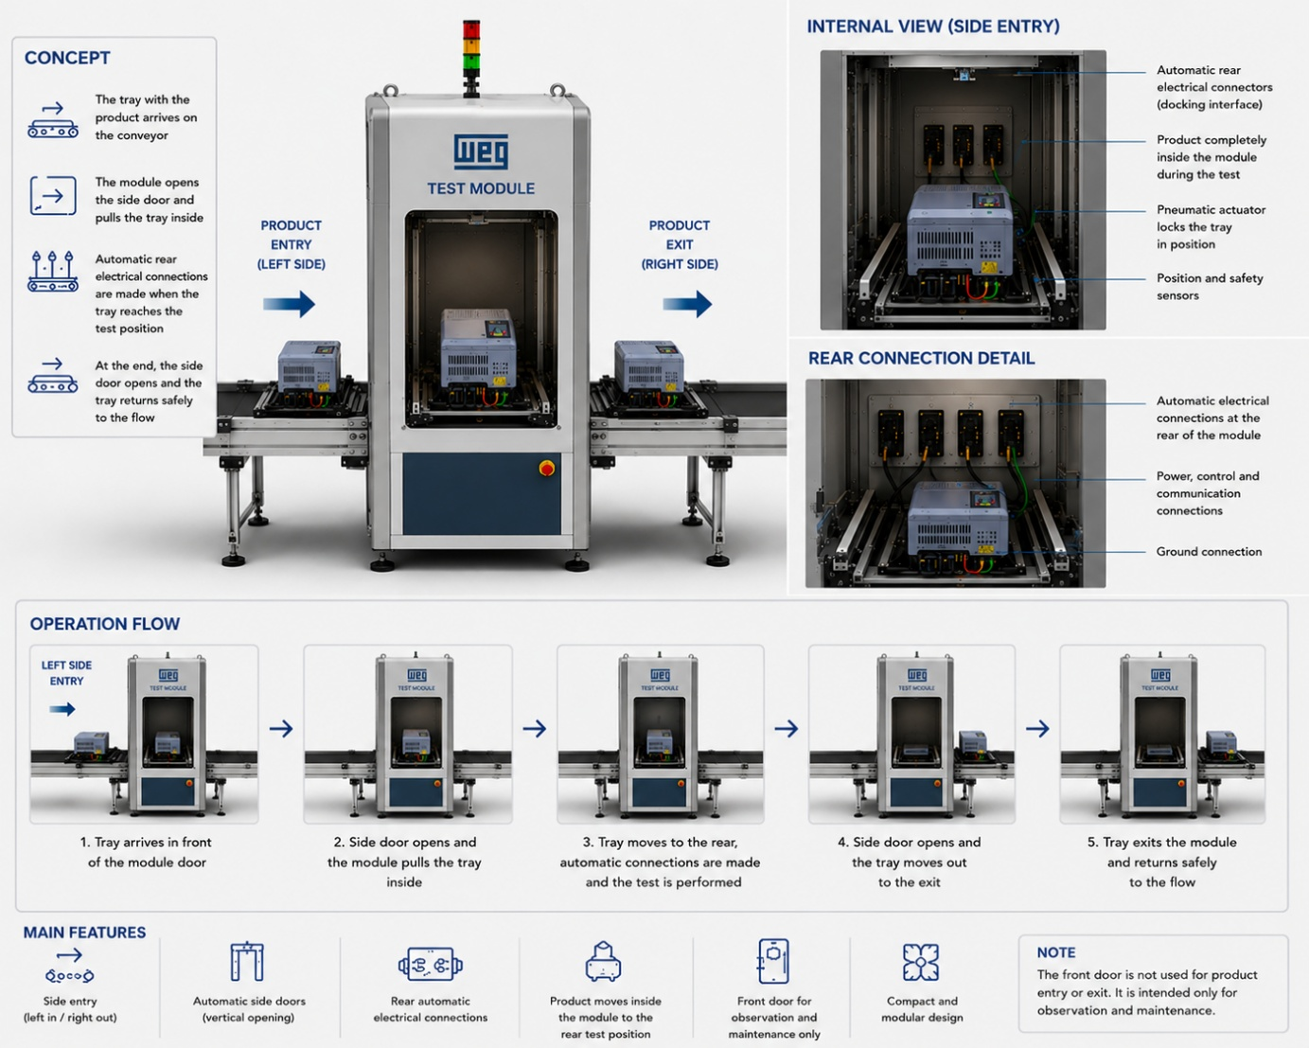
Illustrative imagem of the All Drives test module
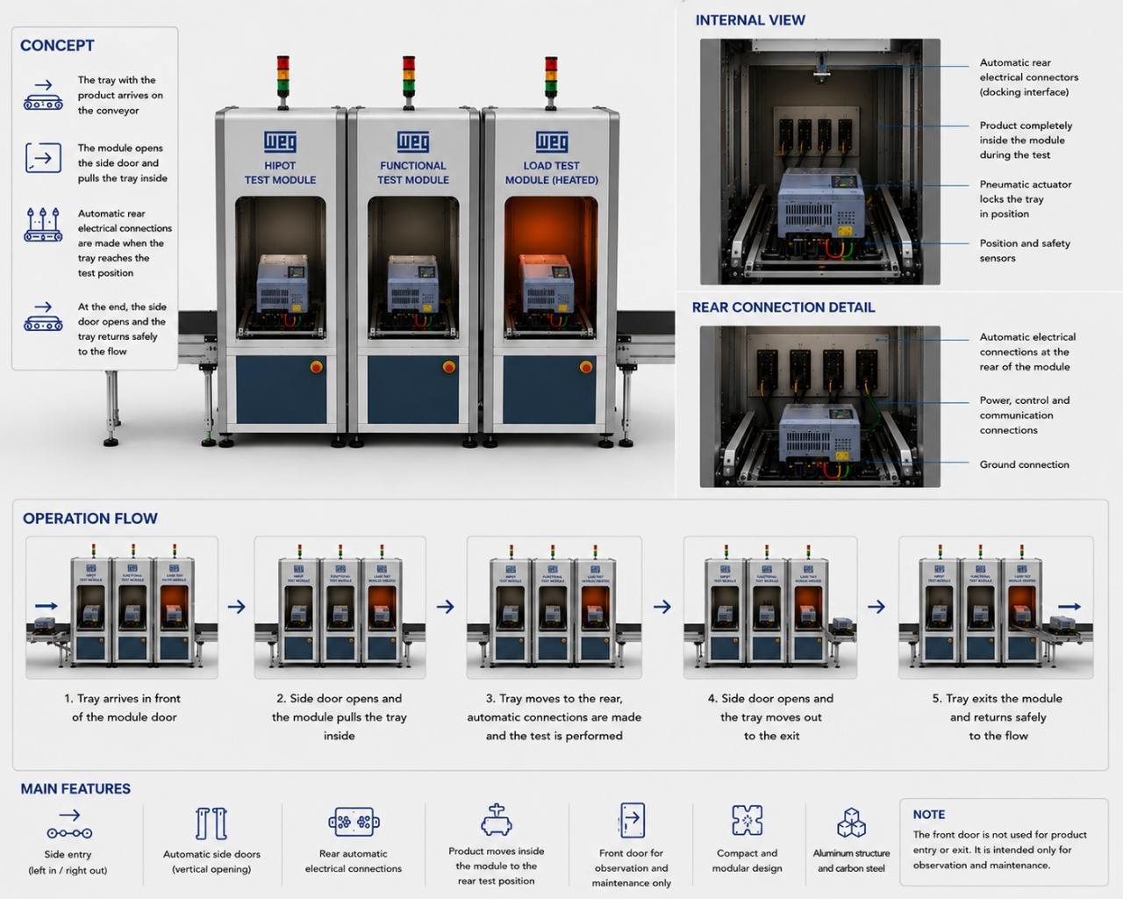
Illustrative image of a complete test line with several Modular All Drives

OPERATIONAL FLOW OF THE MODULAR ALL DRIVES LINE

- Product is assembled on the fixture and connected;
- Automatic QR Code reading by the assembly stage;
- Automatic recipe selection by the system;
- Automatic movement of the product to the hipot and functional test module via conveyor;
- Automatic movement to the test position;
- Connection of the power connections;
- Hipot test execution;
- Connection of the control/IO connections;
- Functional test execution;
- Data recording;
- Approval/rejection;
- Return to the conveyor;
- Automatic movement of the product to the load test module via conveyor;
- Automatic movement to the test position;
- Electrical/mechanical connection;
- Test execution;
- Data recording;
- Approval/rejection;
- Return to the conveyor;
- Final segregation into packaging or repair;

- GENERAL OBSERVATIONS FOR THE DESIGN/MANUFACTURING OF THE MODULAR ALL DRIVES TEST SYSTEM

- Supplier responsibilities:
- Design, build and install a combined hipot and functional test module and a load test module following the Modular All Drives concept according to this specification and applicable standards;
- The project shall comply with safety standards (NR10 and NR12);
- The modules shall have bases with reinforced beams 100 mm high for transportation with a manual pallet truck and flanges on the bases;
- For the protection of the doors and cabin enclosures, 5 mm thick polycarbonate shall be used;
- All material used in the construction of the cabin and enclosure shall be non-combustible. If this is not possible/applicable, it shall be self-extinguishing (flame retardant) and non-toxic in case of fire. The manufacturer's report shall be supplied;
- The structure shall not allow access of body parts into the interior of the cabin with the doors closed;
- Structure and mechanical components: test cabins in aluminum profile and polycarbonate enclosure;
- Prepare the complete project documentation, delivering the electronic files organized in a logical manner, containing the part drawings and complete mechanical assemblies in 2D and 3D CAD format (SolidWorks, Parasolid or similar that can be accessed with SolidWorks 2022) and in 2D PDF files;
- Technical manual with, at minimum: general description of the equipment, basic operating instructions, warranty details, general mechanical drawings (with dimensions and weight of the assembly), detailing of the transportation and lifting process, list with complete technical description, quantity, manufacturer and model of all materials, components and parts used, and periodic maintenance instructions;
- Mechanical and electrical ART (Engineering Responsibility Registration) of design and execution together with any other documents necessary for registration of compliance with the established criteria, safety requirements and other technical responsibilities;
- Define the warranty period of the system;
- On-site and remote technical support options;
- Availability of spare parts;
- Virtual simulation or prototyping for validation.

It is mandatory to mention in the quotation if any item of this specification will not be met or will be partially met. In the absence of comments, we will consider that the specification will be fully met.

